Python DA Assignment 1: Data Analysis using NumPy and
Pandas
Date of Submission : - 10 - 2026
Name : K.Sreelatha

Screen shot:

Numpy Array Operations

1. Create a 1D NumPy Array

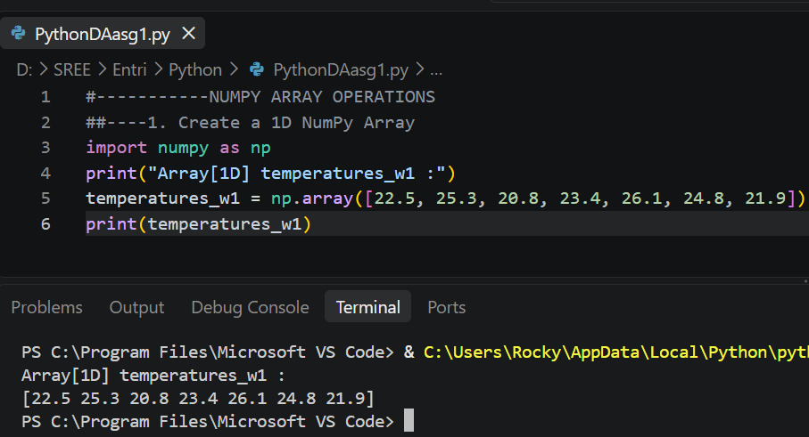

2. Inspection and Properties

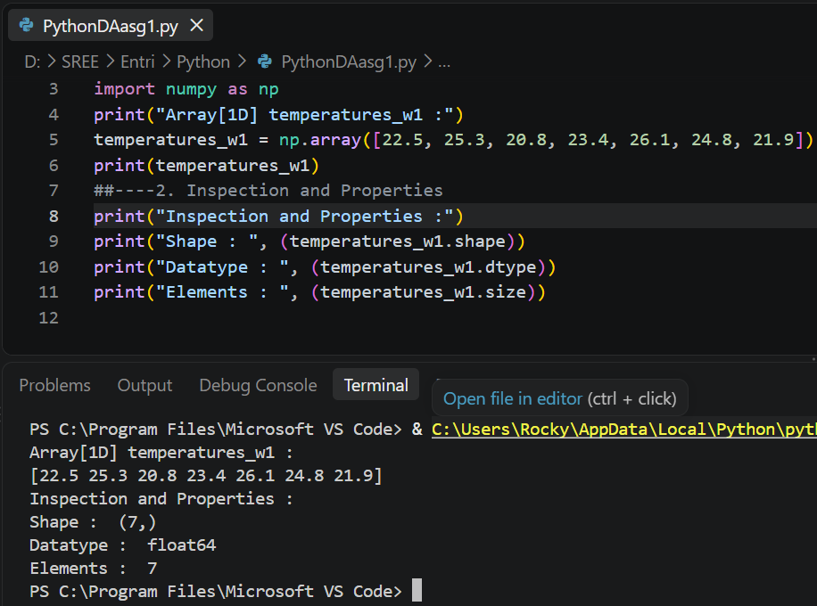

3. Array Operations

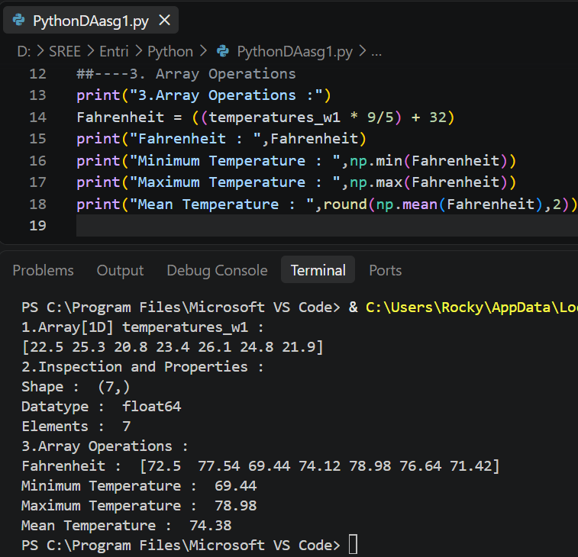

4. Array Slicing and Indexing

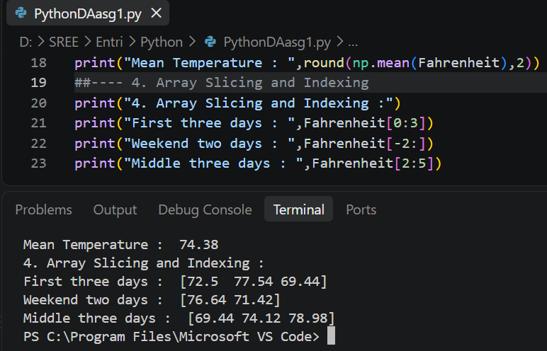

5. Create a 2D Array

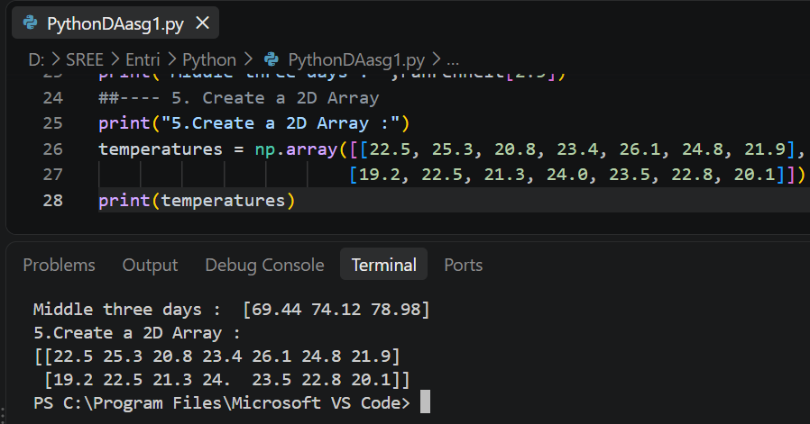

6. Inspect and Slice the 2D Array:

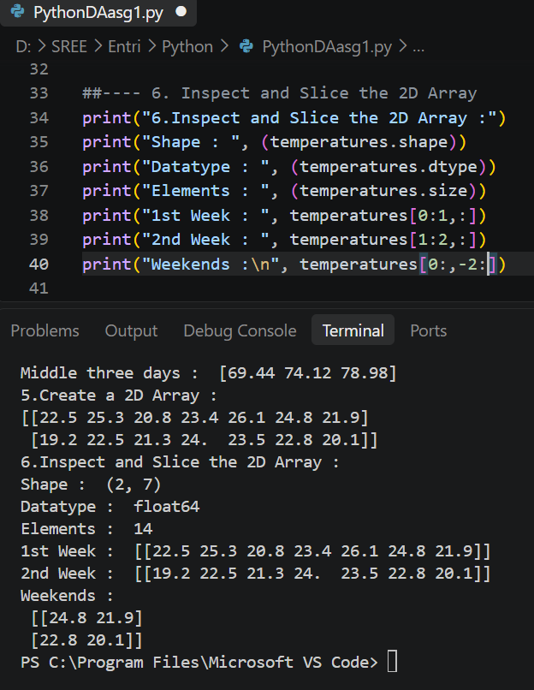

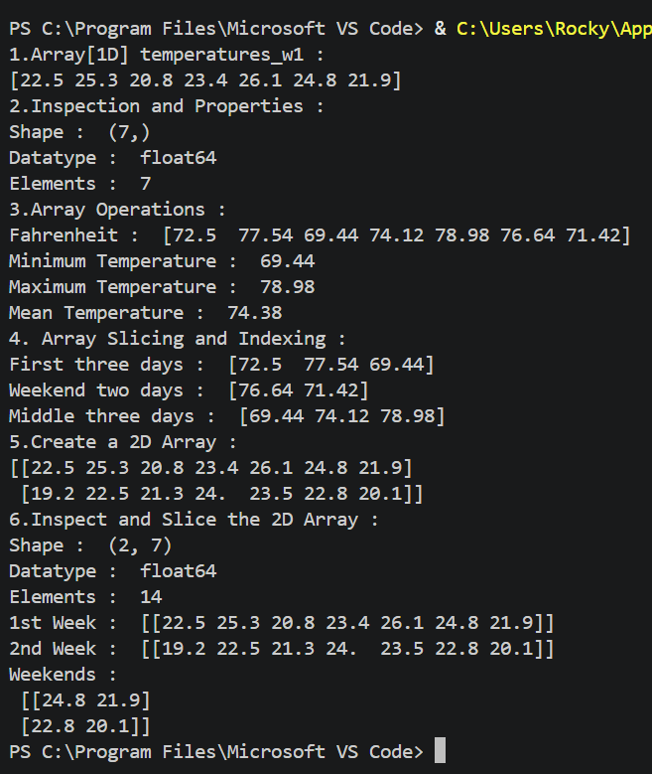

Pandas Series:
1. Creating Pandas Series:
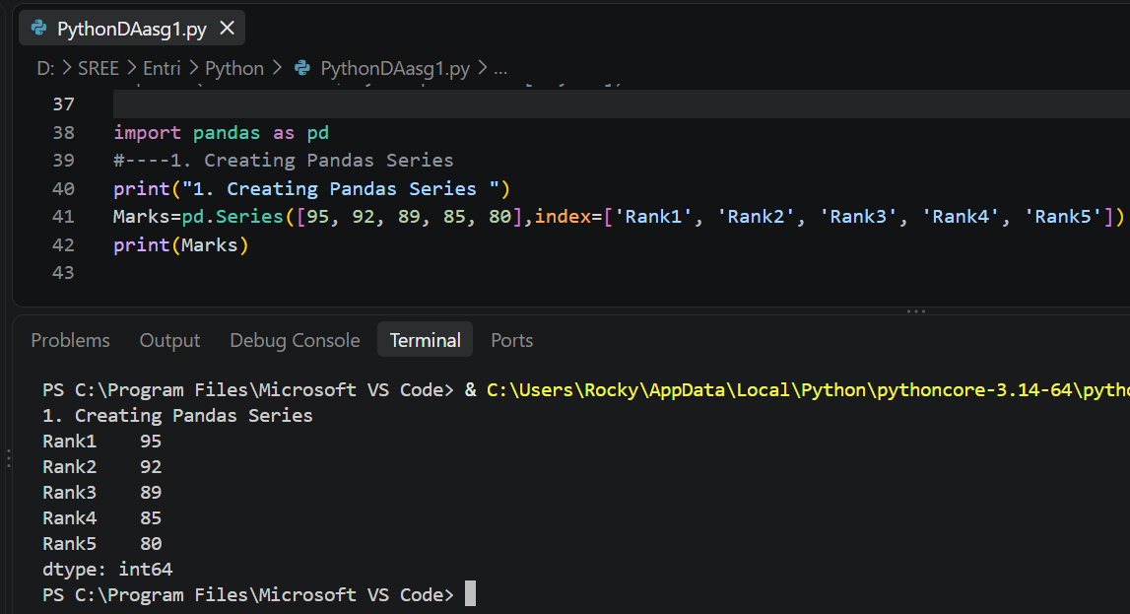

2. Indexing and Slicing:
● Use the integer index position to access the mark of the 1st rank student.
● Use the loc accessor to retrieve the marks of the top 3 ranks by specifying their index labels.
● Use the iloc accessor to retrieve the mark of the 3rd rank student.
● Apply a boolean mask to filter the Series and retrieve the ranks where the marks are greater than 90.

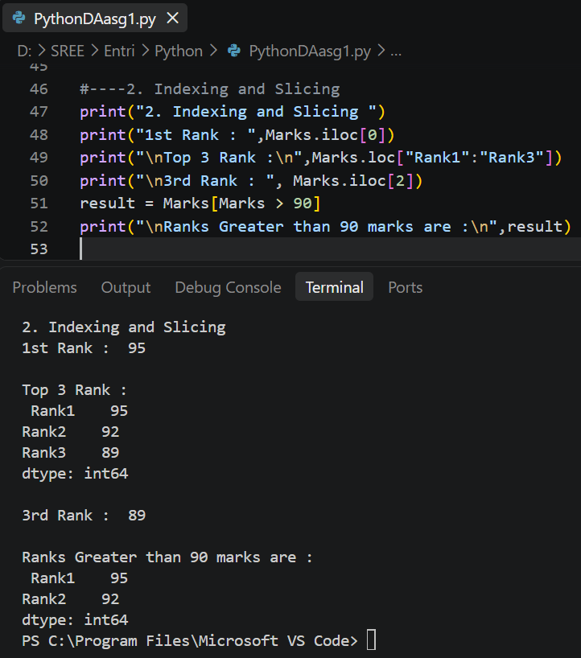

3. Manipulating Series:

Modify the mark of the student with the 1st rank to 100.

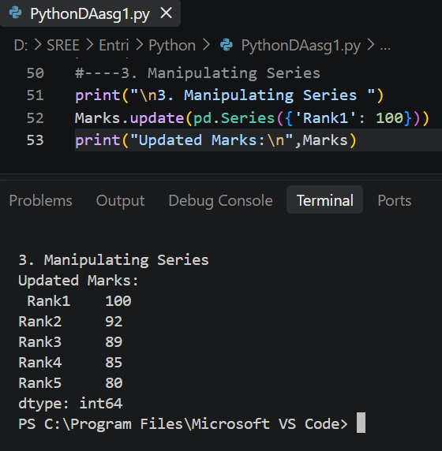

Remove the entry corresponding to the last rank from the Series.

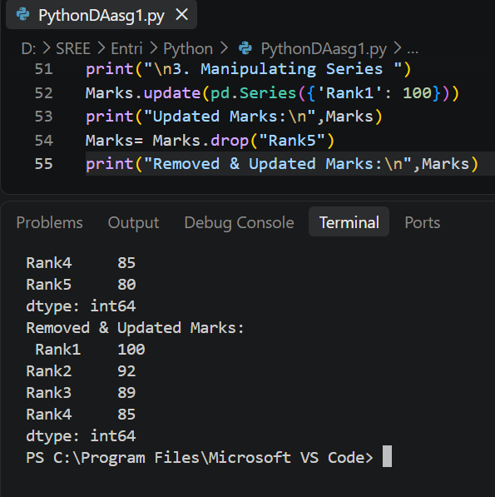

Compute the CGPA by dividing each mark in the Series by 10

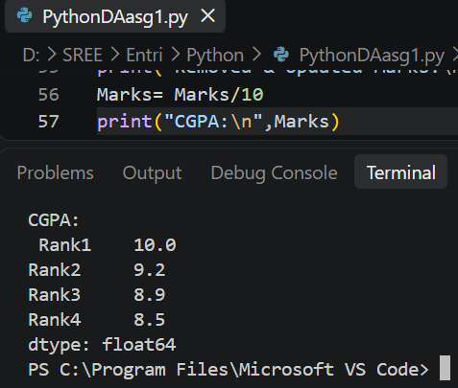
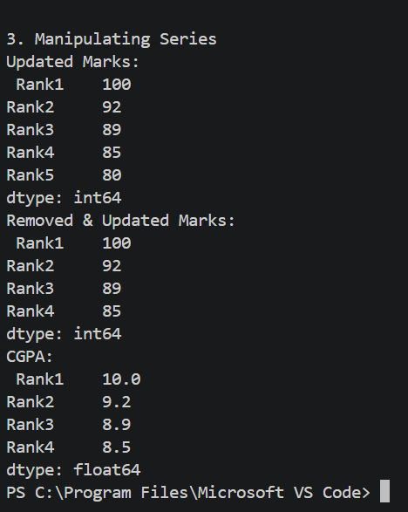
Pandas DataFrame

1. Creating Pandas DataFrame

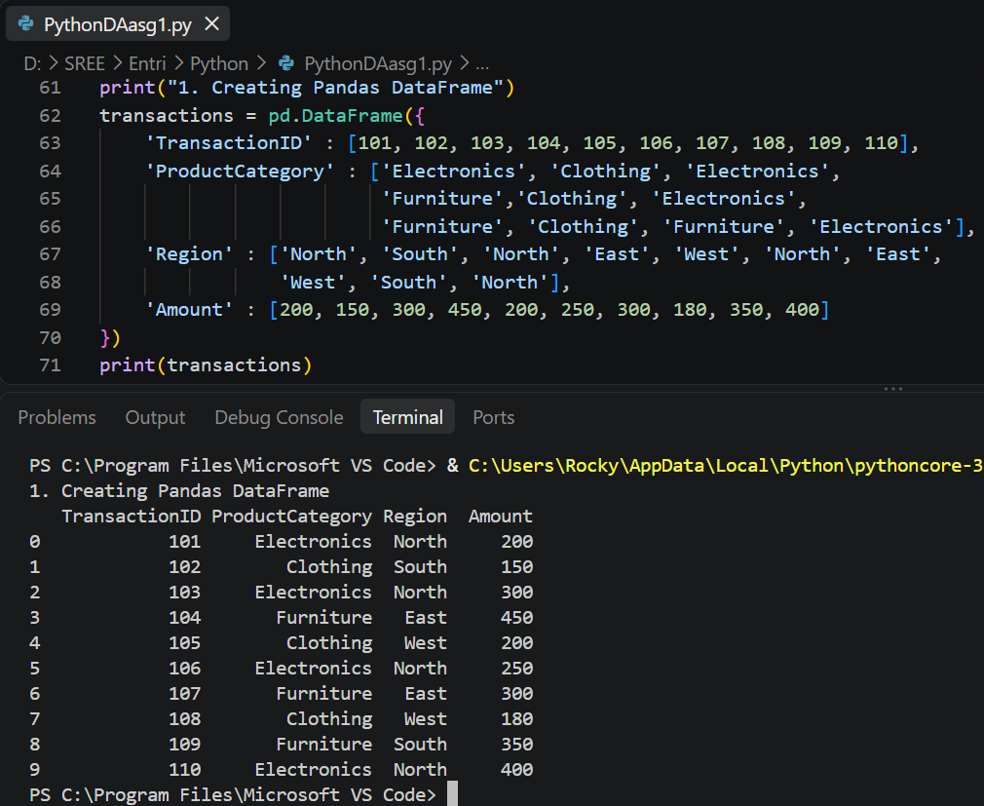

Display the transactions DataFrame and its basic information, including head, tail, shape, column names, and data types.

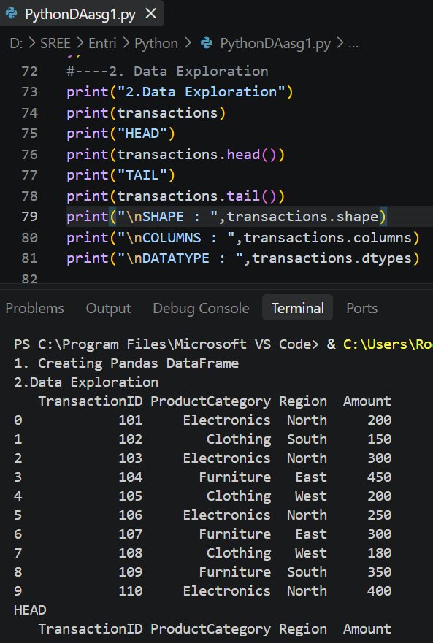

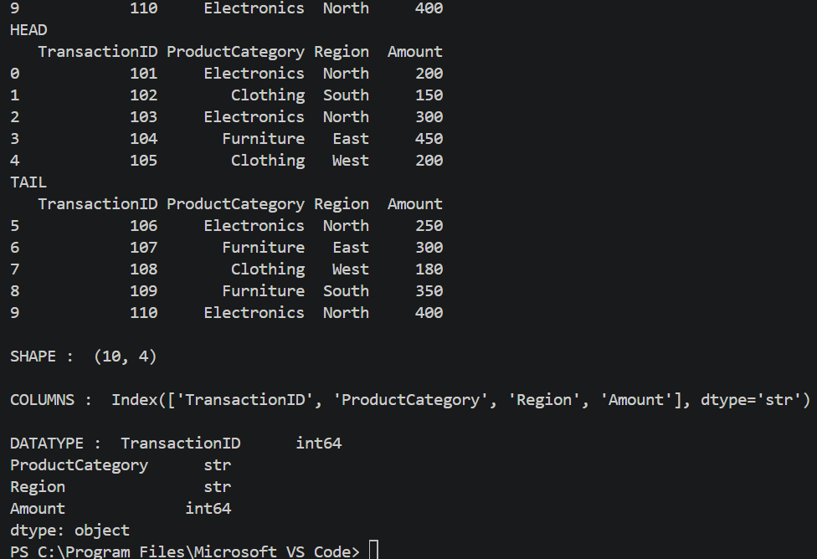

Display only the 'ProductCategory' and 'Amount' columns

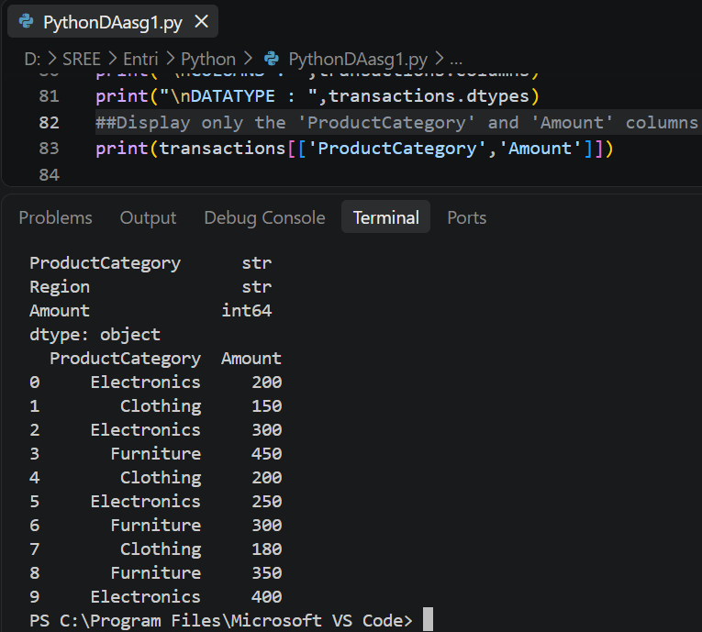

Retrieve the last 3 columns of the DataFrame using iloc or loc

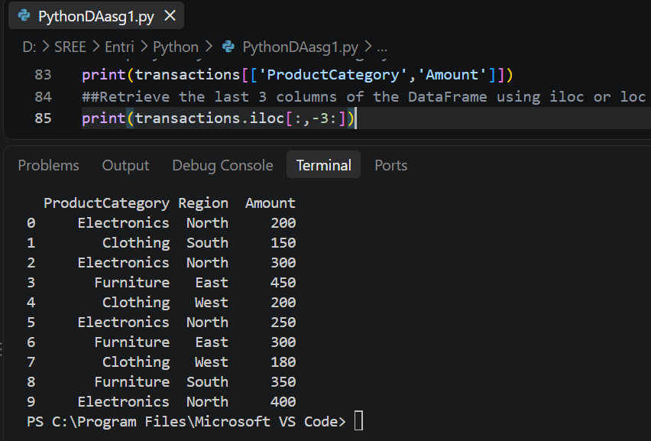

Filter rows where the 'Region' is 'North' and 'Amount' is greater than 200

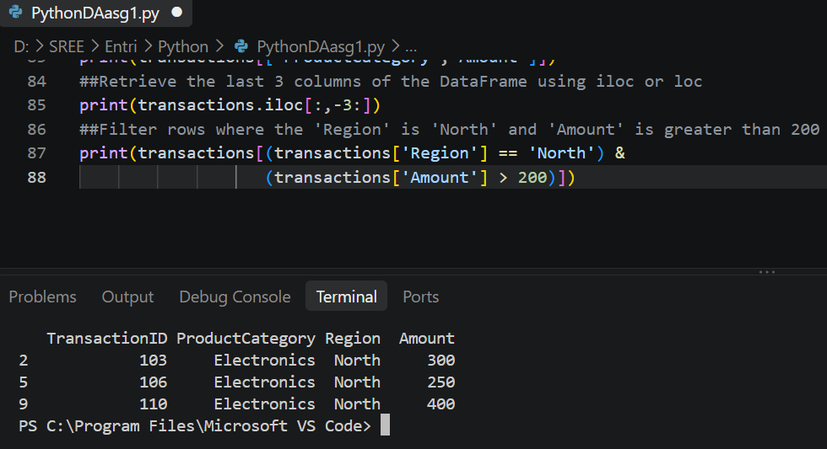

Find the value counts for the 'ProductCategory' column

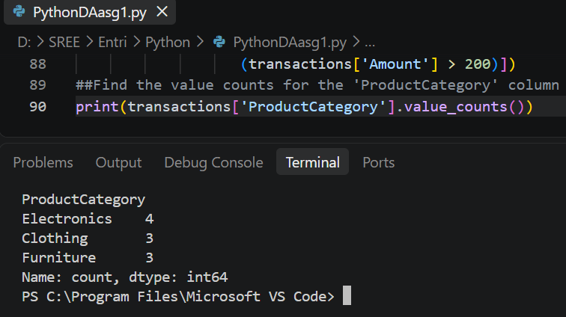

Find the unique values in the 'Region' column

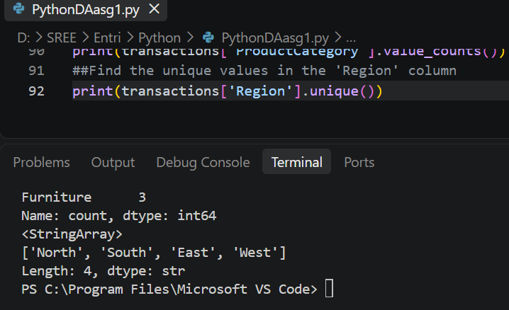

Group by 'Region' and find the mean amount for each region

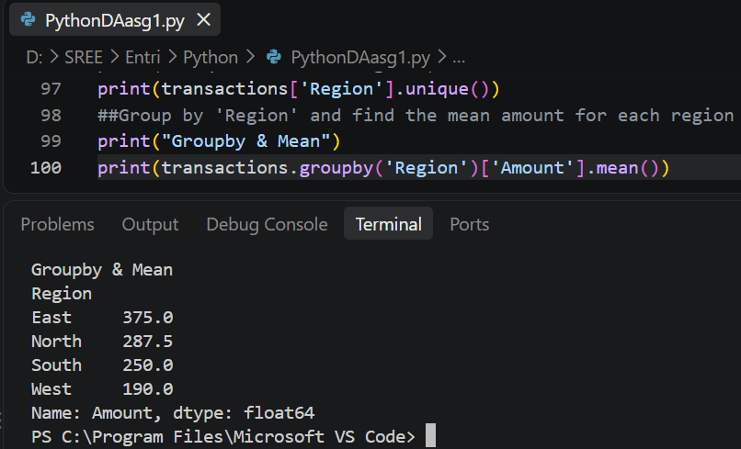
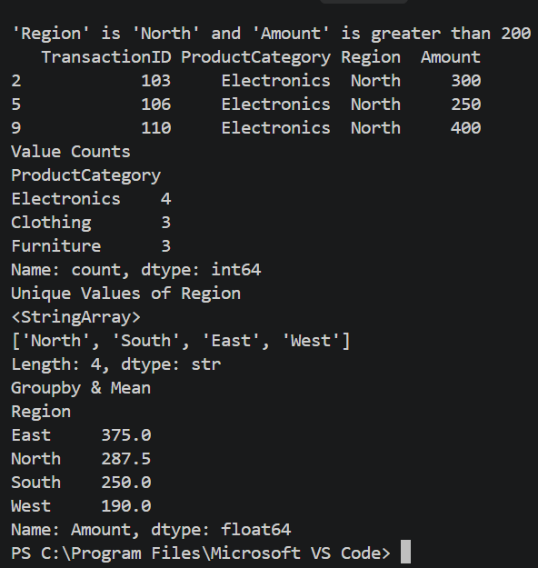
3. Manipulating the DataFrame:

Modify the 'Amount' for the transaction with TransactionID 102 to 165

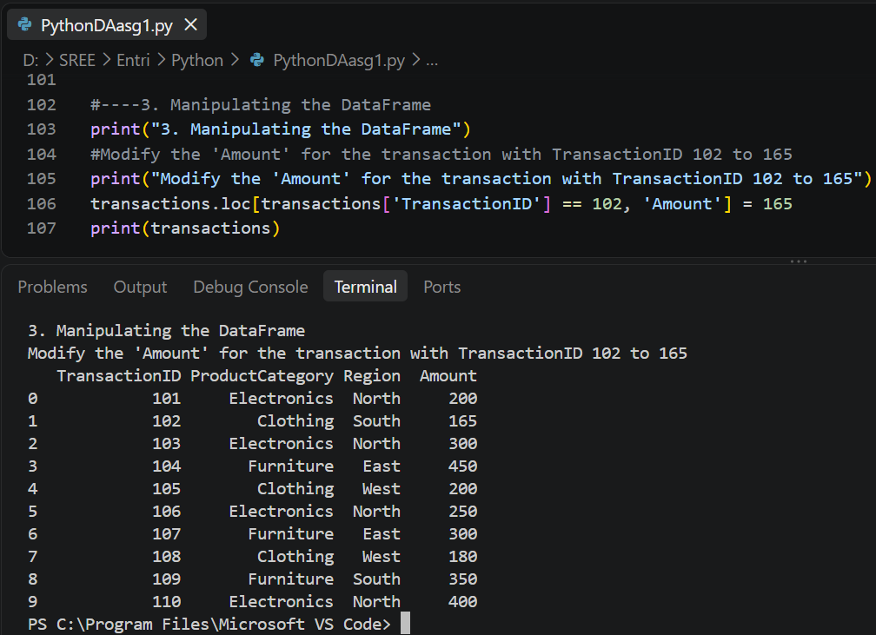

Add a new column 'Discount' by calculating 10% of the 'Amount'

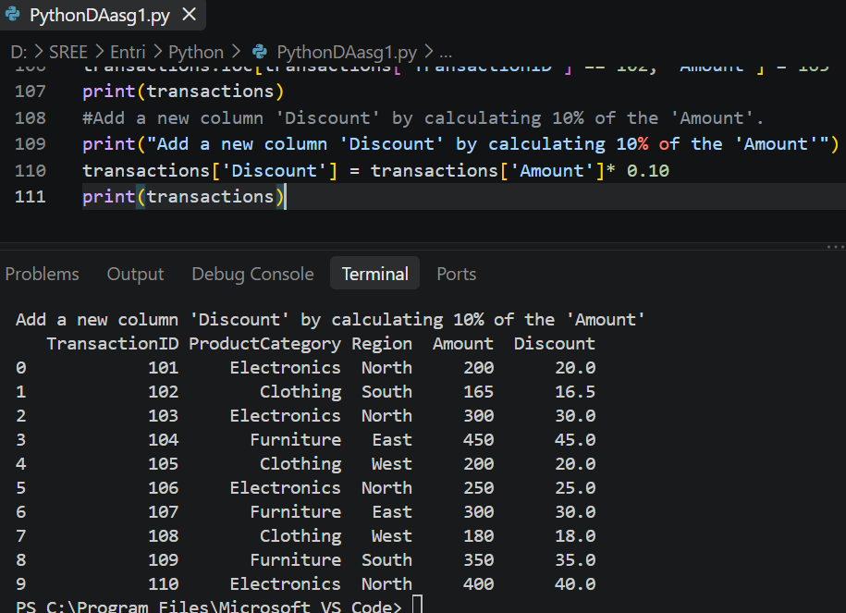

Remove the row with TransactionID 109.

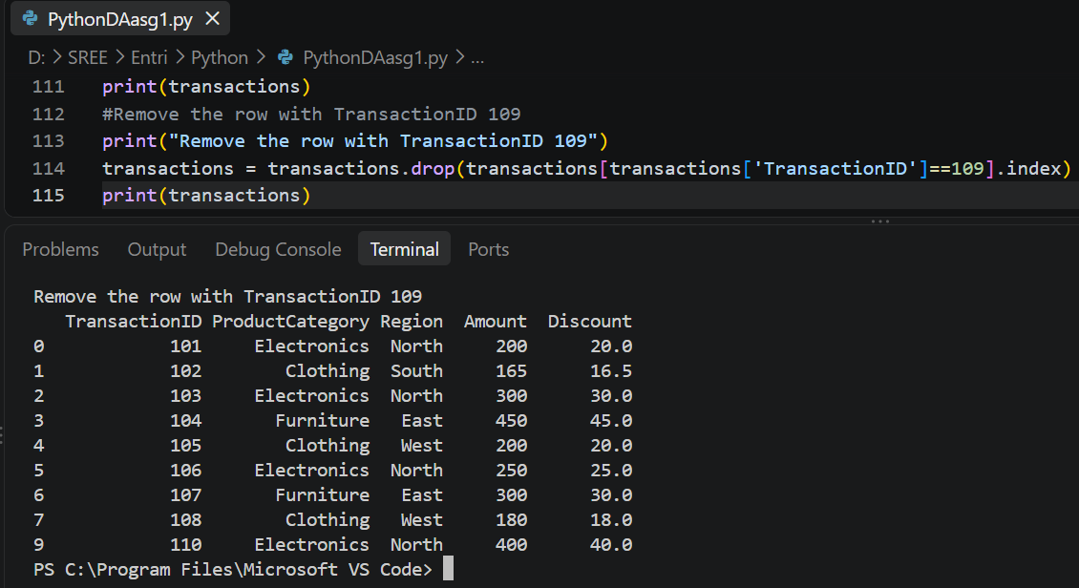

Delete the 'Discount' column from the DataFrame

